NFL Blitz 2000 Step-by-step

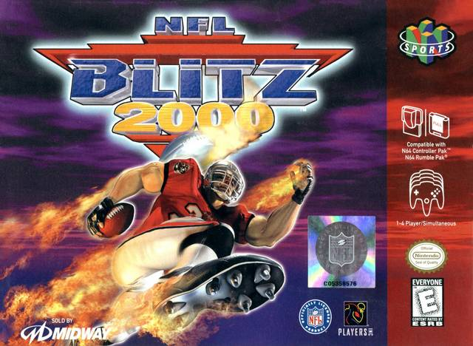
Created by UltraMagnus
2021

NFL BLITZ Step-by-Step
Items that you will need to get started (all included):
- Blitz Roster Manager 2.0 (team/roster editor) created by Zonkity and Jaker3 on NFL Blitz Fans - Index
- Graphic Editor (used to change images) created by Zonkity and Jaker3 on NFL Blitz Fans - Index
- xdeltaUI (program to patch updates) created by Zonkity and Jaker3 on NFL Blitz Fans - Index
- Patches (2018 patch) created by Zonkity and Jaker3 on NFL Blitz Fans - Index
- Original version of NFL Blitz 2000 (USA).z64
- Images you would like to use (provided examples)
- Player Information that you would like to be used.

Once, you have all this information, you are ready to create your own version of NFL Blitz. Follow these steps to get you on your way.

- Open xdeltaUI program.
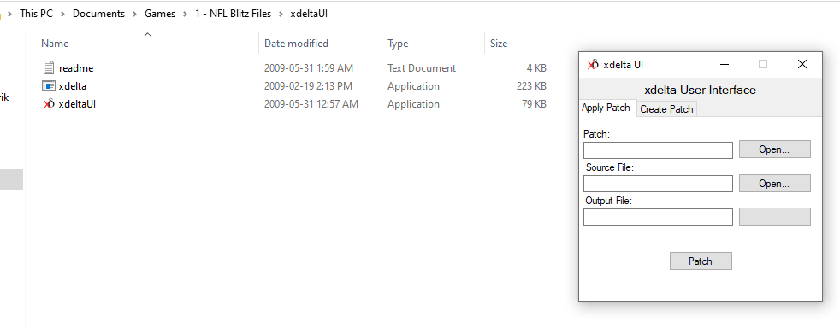
- Select OPEN on the Patch line, and find the patch you will use to apply to the rom. The version being used is called “NFL Blitz 2018 Patch.xdelta” and click OPEN.
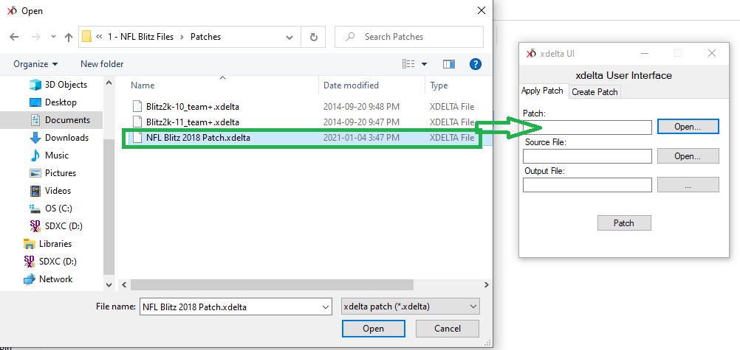
- Now repeat for the Source File, which will be the NFL Blitz 2000 (USA).z64 rom. Select the file and click OPEN.
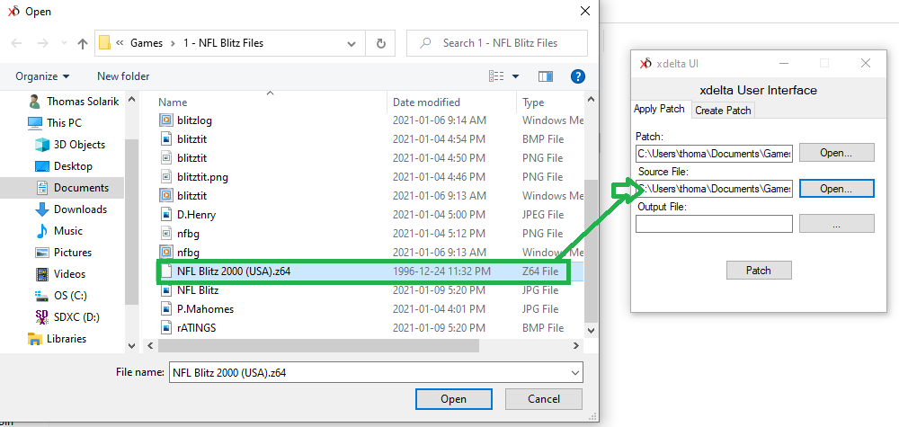
- Lastly, click on the ( … ) for your Output File, will be what you would like the name of the rom to be (ie NFL Blitz 2K21). Click OPEN.
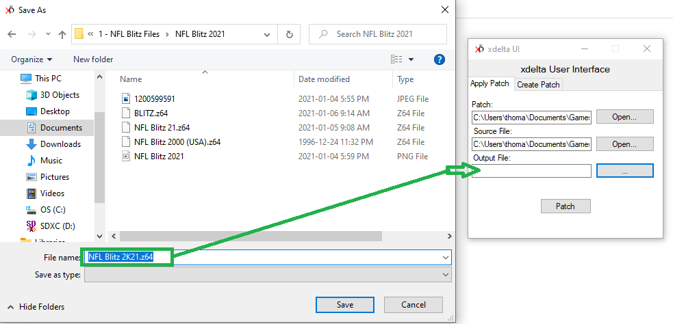
- Finally, click PATCH. This should have a small window pop-up say, “File Patched Successfully”.
- Your NFL Blitz file is ready for the next step.

Now, if you want to change some of the images. Follow these steps.
- Open folder named, “Graphic Editor”, and select NFL Blitz File Editor.
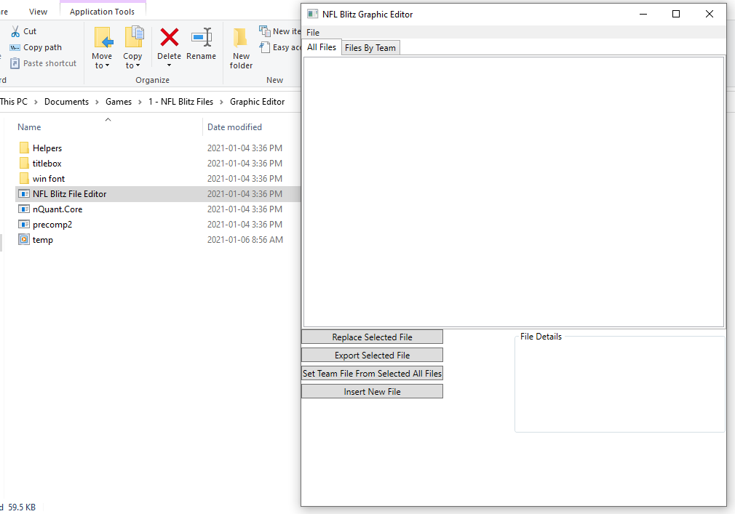
- Find the file you created above (ie NFL Blitz 2K21) and open it.
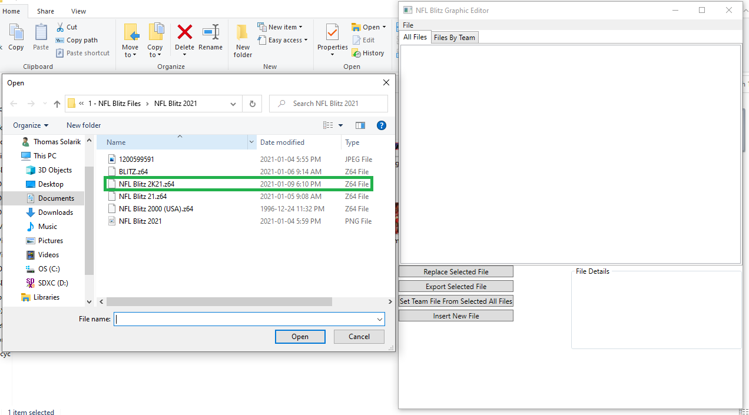

- Your window should look like this.
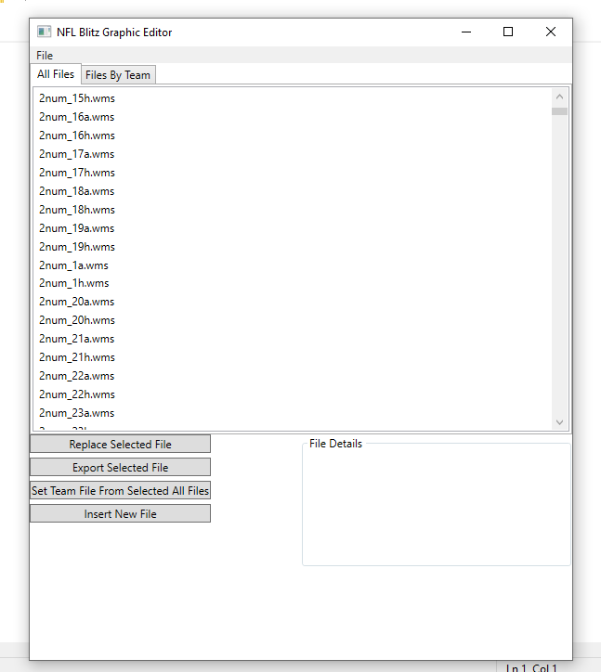
- Your now ready to make some graphical changes. Your can filter through teams also, if there is a specific team you’re looking for. Let’s start with the main splash screen. Scroll through the files and find “blitztit.wms”. Once you find it, your screen will look like this.
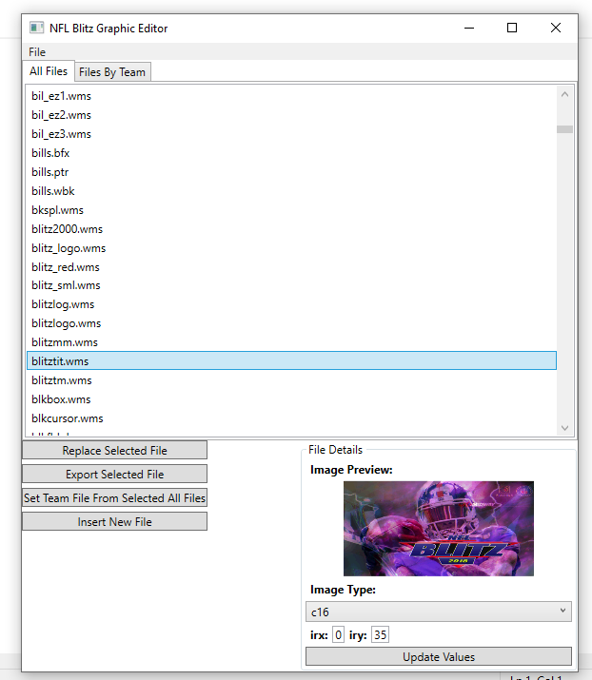

- Click on EXPORT SELECTED FILE to get the dimensions of the images you will need to import or change. This image is 512 x 256 and save the image as a bitmap (.bmp). Find a location to keep all your exported files and make sure you save this exported file as “blitztit”.
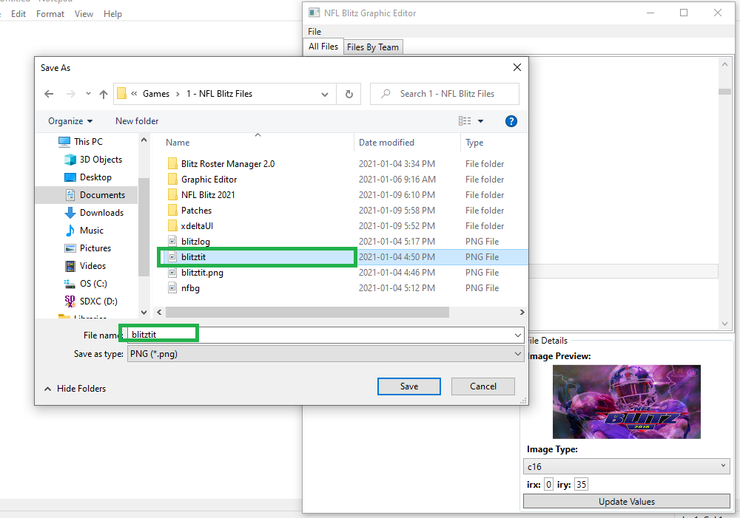

- When you create your image in a 512 x 256 make sure you save it as a .bmp and name it the same file name you are replacing. This will mess up the game if it is not named the same. Here is a version I created.
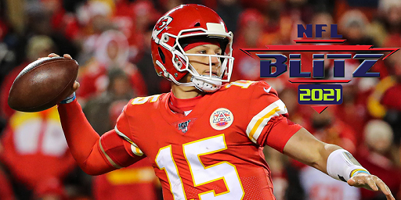
- When you are ready to import that image you created. Select “Replace Selected File” and find the one you had created. Then click OPEN. The application will run its program to compress the file into the game. Let it run for about 10 seconds.
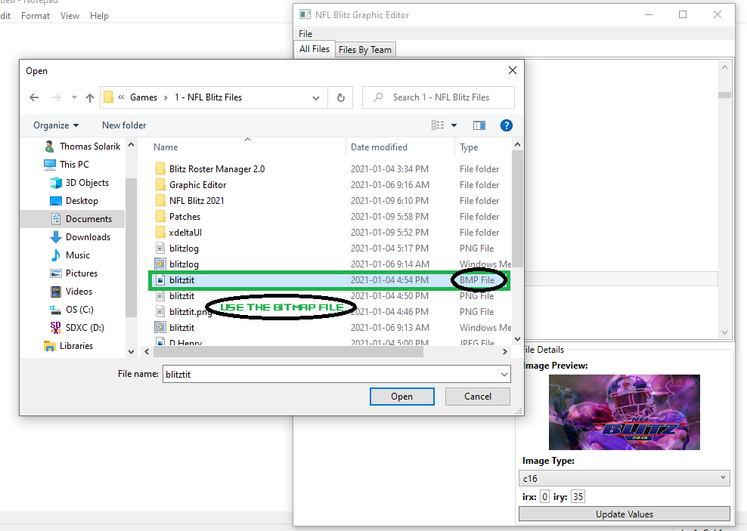

- Now, find “blitztit.wms” again and the image will have been replaced with your personalized one.
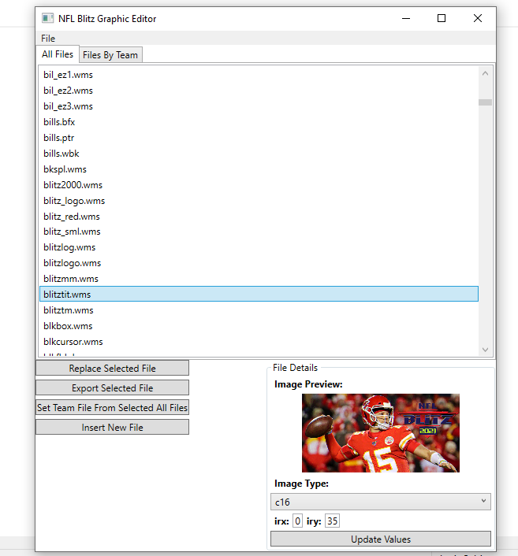
- Run your rom to test it to make sure it works. Open your Project 64, or whatever emulator you are using for N64 games and this should populate your new intro screen.
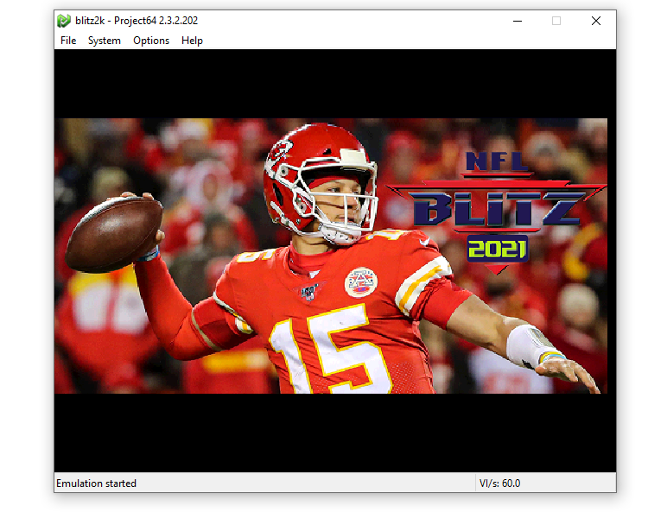
- Now you can do the same for anything in the game, but make sure you copy the same templates.

Now, if you want to update the rosters. Follow these steps.
- Open Blitz Roster Manager 2.0, and make sure you make these adjustments highlighted in GREEN, before selecting you file. Ill be using the same one “NFL Blitz 2K21”. Once you have set the SYSTEM: area to N64 and the GAME: to Blitz 2000 Zonikty, select PULL ROSTER FROM ROM. Find your file and click OPEN.
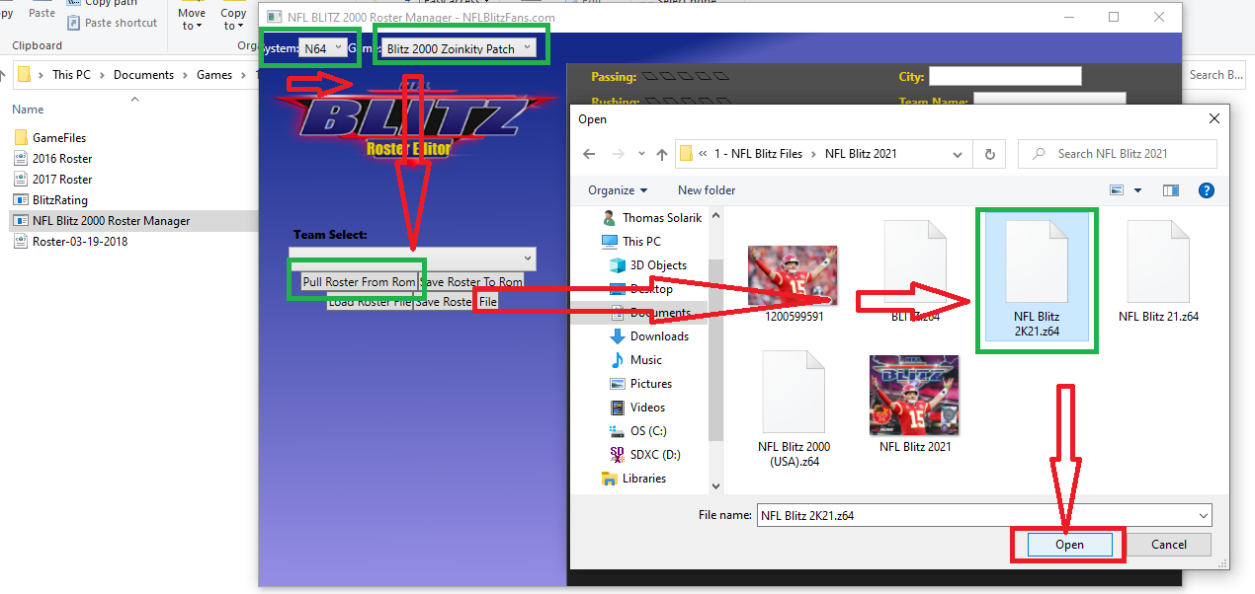
- Go, to TEAM SELECT and you now can update the rosters, including the Houston Texans.
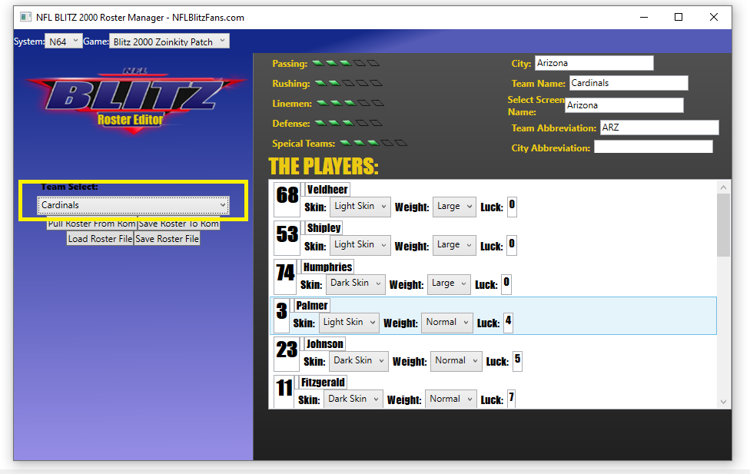
- Once you have completed your roster adjustments. Click “Save Roster to Rom” and save a back file in case with “Save Roster File”.

From LINDY PRO FOOTBALL 2020-21 Season
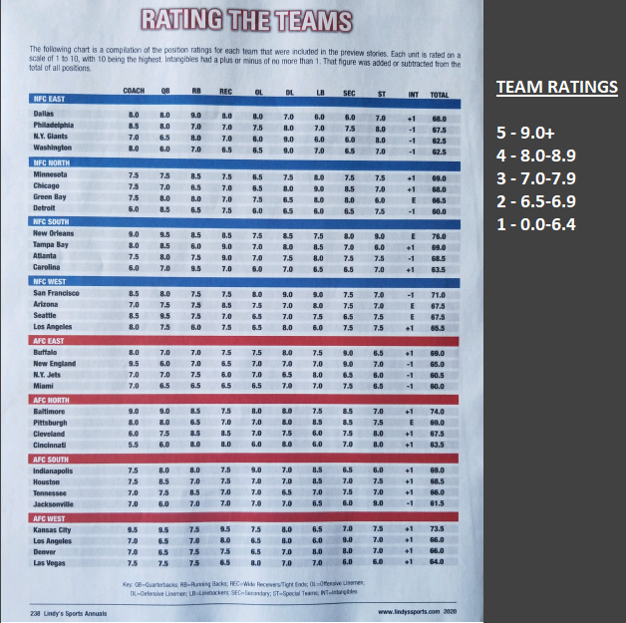
Rush = OL + RB / 2
Pass = WR + QB / 2
DEF = DL + LB + DB / 3
OFF + WR + OL + RB + QB / 4
Team | RUSH | PASS | OL | DEF | ST
ARI | 3 | 4 | 3 | 3 | 3
ATL | 3 | 4 | 3 | 3 | 3
BAL | 4 | 4 | 4 | 3 | 3
BUF | 3 | 3 | 3 | 4 | 2
CAR | 4 | 3 | 1 | 2 | 3
CHI | 2 | 3 | 2 | 4 | 3
CIN | 3 | 3 | 1 | 3 | 4
CLE | 4 | 4 | 3 | 3 | 4
DAL | 4 | 4 | 4 | 2 | 3
DEN | 3 | 3 | 2 | 3 | 3
DET | 1 | 3 | 1 | 1 | 3
GB | 3 | 3 | 3 | 3 | 1
IND | 4 | 3 | 5 | 3 | 1
JAX | 3 | 2 | 3 | 2 | 5
KC | 3 | 5 | 3 | 3 | 3
LV | 3 | 3 | 4 | 2 | 1
LAC | 2 | 3 | 2 | 3 | 3
LAR | 1 | 3 | 2 | 3 | 3
MIA | 2 | 2 | 2 | 3 | 2
MIN | 3 | 3 | 2 | 3 | 3
NE | 3 | 1 | 3 | 3 | 3
NO | 4 | 5 | 3 | 4 | 5
NYG | 3 | 2 | 1 | 3 | 4
NYJ | 3 | 2 | 3 | 3 | 1
PHI | 3 | 3 | 3 | 3 | 4
PIT | 2 | 3 | 3 | 4 | 3
SF | 3 | 3 | 4 | 5 | 3
SEA | 3 | 4 | 2 | 3 | 3
TB | 1 | 5 | 3 | 3 | 1
TEN | 4 | 3 | 3 | 3 | 3
WAS | 2 | 1 | 2 | 3 | 3

